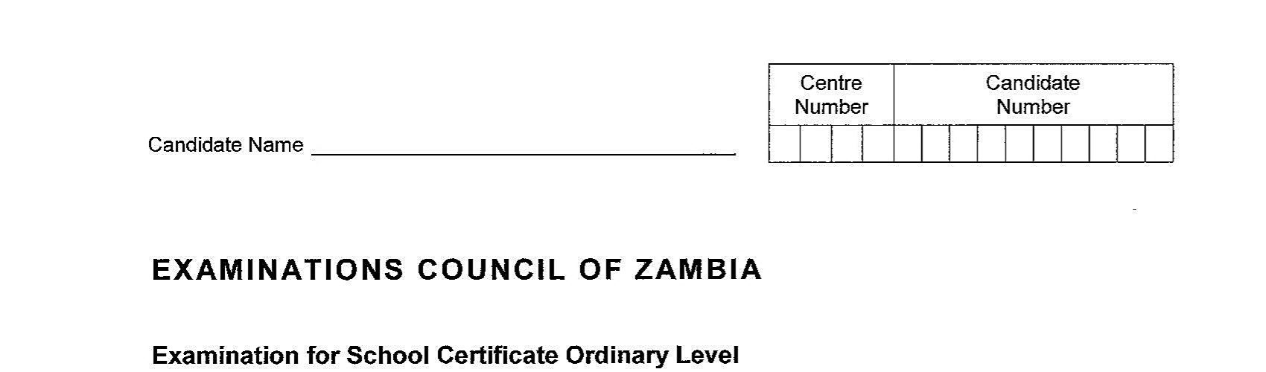
Name …………………………………………………………

MINISTRY OF GENERAL EDUCATION
CHINGOLA DISTRICT COMMON END OF TERM 1 TEST

Examination for General Certificate of Education Ordinary Level

Design and Technology 7TH APRIL 2022 6045/1
Paper 1 (Theory & Design)
Grade 12 – 2022
Additional Materials:
A3 Drawing paper
Drawing Instruments

Time: 2 hour 30 minutes Marks: 110

Instructions to candidates
- Write your name, center number and candidate number, in the spaces at the top of this page and on the separate Answer booklet provided by yourself.
- If working is needed for any question, it must be shown in the spaces provided in the question paper and answer booklet.
- There are two sections in this paper. Section A and B. answer all questions in section A. write your answers in the spaces provided in the question paper.
- Section B has three parts I, II and III. Part I is compulsory.
- Answer one question in part ii and one question in part iii. Write your answers in the answer booklet you have provided.
- The question in part III should be answered on the A3 drawing paper you have provided
- Where a freehand sketch is required, it must be drawn to half full size
with good line work.
- At the end of the examination fasten the answer booklet and drawing paper used securely to the question paper,

Information for candidates
- The number of marks is given in brackets [ ] at the end of each question or part of question.
- Use of color is allowed.
- All dimensions are in millimeters
- Cell phones and calculators are not allowed in the
examination room.
For Examiner’s use
Section A
Section B
Part I
Part II
Part III
Total
Section A [30 marks]
Answer all the question in the spaces provided on this question paper.
If working is needed for any question, it must be shown in the space below that question.
- (a) Figure 1 shows one of the holding tools used in the Design and Technology workshop.
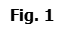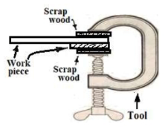
i) Give the name of the tool in figure 1
………………………………………………………………….……………………………..……. [1]
ii) State one reason why it is necessary to place scrap wood underneath the work
piece when drilling. .……………….…..…………………………………………………….……….
………………………….……………………………………………………………………………………... [1]
iii) In what group does the tool mentioned in figure 1 belong to?
……..…………………………………………………………………………………………………. [1]
(b) i) State the function of a mallet
……………..…………………………………………………………………………………………… [1]

ii. State any one suitable material used in making the head of a mallet.
…………………………………………………………………………………………………….... [1]
iii. One of the safety precautions to observe when working with a mallet is to use a
correct mallet for the right job. Suggest one other safety rule to observe.

…………………………………………………………………………………………………………………
[Total: 6 marks]

- a) Figure 2 below shows a bicycle.
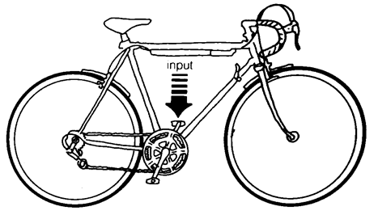

Fig. 2
    - If the direction of input is as shown, what will be the resultant motion on the wheels?
……………………………………………………………………………………………………….. [1]
    - One type of mechanism is rack and pinion. Name one other type and give an example were it is used
Mechanism: ……………………………………………………………………………………….. [1]
Use: ………………………………………………………………………………………..………. [1]

b) Figure 3 shows an electric circuit diagram.
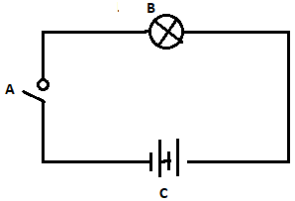
Identify the components labeled A, B and c
A ………………………………………………………………………………………………………….. [1]
B …………………………………………………………………………………………………………… [1]
C …………………………………………………………………………………………………………… [1]

- a) Figure. 4 shows views of a smart phone desk stand

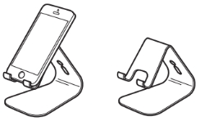
Fig.4

- Suggest the material from which the above stand can be realized.
…………………………………………………………………………………………………………….… [1]
- State two reasons for your choice of materials
…………………………………………………………..………………………………………….………
………………………………………………………………………………………………………….…… [2]

- The table below shows incomplete information in industrial engineering in relation to electrical principles. Fill in the boxes.
Name of device | Symbol
Isolator
 | 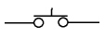
Bell
[3] [Total: 6 marks]

- (a) Figure 5 shows a roof structural construction.


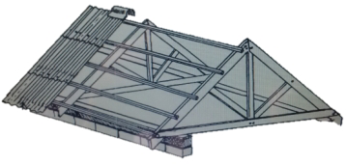

Fig. 5

i) Name parts labelled G and H
G ................................................................................................
H …………………………………………………………………………………….......... [1]

ii) State one type of roofing structure
…………………………………………………………………………….. [1]
iii) Name one type of roof covering of a building structure.
...................................................................................................... [1]

(b) Explain safety rules to be observed when carrying out the following processes.
i) When welding: ………............................................................................................
…………………………………………………………………………..…………………. [1]
ii) Melting plastics: …………………….………………………………………….……………..………….……
………………………………….…………………………………………………………….. [1]

- Figure 6 shows a component being prepared for a spare part to be used on the Centre lathe.

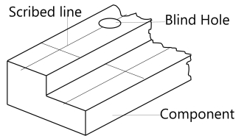
Fig. 6
- What tool was used to scribe the line shown on the component?
Tool: ............................................................................... [1]
- What tool can be used to determine the depth of the blind hole?
......................................................................................... [1]

(b). The blind hole was drilled in readiness for cutting internal threads manually.
- Name the taps in their correct sequence for cutting internal threads.
Tap1....................................................................................................... [1]
Tap 2: .................................................................................................... [1]
Tap3: ....................................................................................................... [1]

- What is the purpose of the centre punch in the process of drilling the hole?
Purpose: ...................................................................................................
…………………………………………….................................................................... [1]

[Total: 6 marks]

Section B [80 marks]
There are three parts in this section. Part I, is compulsory. Part II and III, answer
one question from each part.
Part I Compulsory

- Study Figure 7 and refer to it as you answer the questions that follow. In homes and hotels, Food is often moved from the kitchen to the place where it is to be eaten.

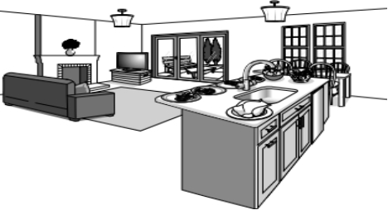
Fig. 7

(a) i. Suggest theme in reference to the situation above. [2]
ii. Identify the problem from the situation in reference to your suggested
theme in (a) i. above [2]

(b) i. Derive a design brief from the problem in (a) (ii) above. [2]
ii. Using illustrations with annotations, design and sketch a unit which will
allow dish (es) of food to be moved at the same time [12]

- List three specifications which could be considered when coming up with
your design solution. [3]

(c) To come up with a perfect solution to your problem, you are expected to do a research.
i) Give two reasons for doing research. [2]
ii) Mention two possible areas of research. [2]
[Total 25 marks]

Part II Answer one question
- (a) Figure 8 shows a menu board for the tuck-shop which is to be made by design and technology pupil in a school workshop.
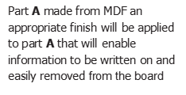
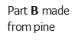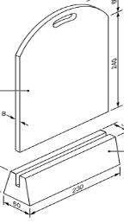
Fig. 8

i) Illustrate, with the aid of sketches, the procedure of realising the menu board. [12]
ii) With regard to its use, what best finish can be applied to the menu board [2]
iii) State the reason for your choice of finish [2]

b) Blessings stated the following specifications in her Grade 12 portfolio booklet:
light materials, opaque finish, permanent joints. For each type of specifications

i) State specific names of materials for each specification she stated. [3]
ii) Give a reason for her choosing:
Light materials [2]
Opaque finish [2]
Permanent joints. [2]
[25 marks]

- a) Figure 9 shows some wasting tools used in design and technology

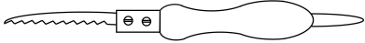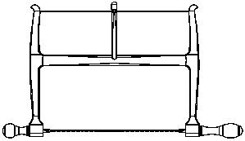
A B
Fig. 9
i. Name the above wasting tools and state their uses [4]
ii. Like wood and metals, plastic can also be shaped using the method called wasting
of material.
Explain the term.
Wasting of materials [2]
Ripping [2]
Kerf [2]
iii. Give two methods of application of preservatives to converted timber. [2]
iv. Make a sketch of a key holder of any shape but it should have at least a curve [2]
V. State and briefly explain the stages of saw reconditioning. [5]

- Any business enterprise comes with challenges unique to the size and function of the
business.
ii) List at least two challenges that are faced by the business owner. [2]
ii) Write down two benefits of someone engaging in entrepreneurship activities. [2]
iii) List two skills of a good entrepreneur [2]

[25 marks]

- (a) The figure below shows a diagram of a machine found in the design and technology
department.

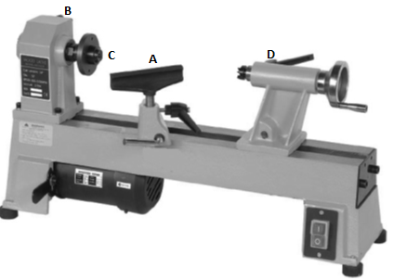
Fig. 10

- Name the parts labelled B and D. [2]
- Describe the function of part A [2]
- State two safety precaution when using lathe machine [2]
- Give one reason why lathe tools have long handles [2]

- Choosing suitable materials for a specific purpose is important in technology. The table below shows some products that can be made in the workshop.
  - Complete the table below by adding the missing information.
Product | Suitable material | Reason for choosing this material.
Bottle Opener
Comb for grooming hair

Drawing Board

[6]

c. A current of 2A flows through a conductor. The conductor has a voltage of 12V across it.
Calculate:
    - Resistance of the conductor? [2]
    - Voltage across a 1.5 Ω when a current of 4A flows through it. [2]
d. i. What is Triangulation? [2]
ii) Loads that exerts force on structures acts on structural members in various
ways. Describe with clear examples each of the following ways.
Tension [2]
Compression [2]
Shear [2]
[25 marks]

Part III Answer one question.
- Figure 11 shows a drawing of a metal template. Construct full size the given view
template clearly showing all points of tangency.
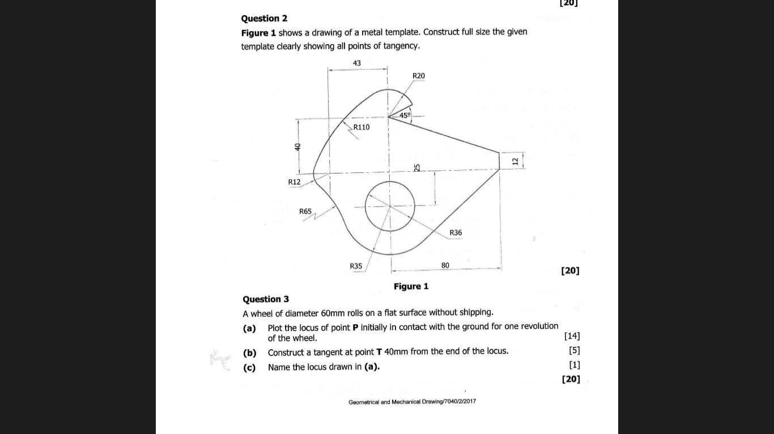

Fig. 11
[Total: 30 marks]

- Museke, a student of Design and technology was asked to Design and make flower
pot to be used by the school. The chosen solution of design of the flower pots is a
shape of a circular cross section of a cylinder as shown in figure 11.

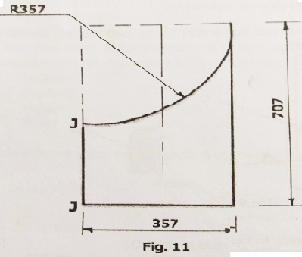

Fig. 12

Draw the surface development of the design using scale of 1: 7 having the
cutting seem at J-J

